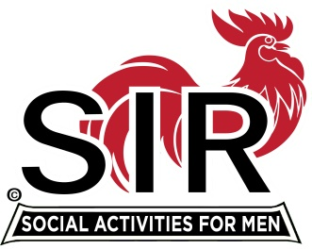
Las Trampas Branch 116
BEC Meeting Agenda
February 17, 2020, 9:30 AM
The Mission of SIR is to enhance the lives of our members through fun activities, events and luncheons – while making friends for life.

09:15 Coffee Available
09:30 Call to order; Secretary confirm a quorum
09:31 Secretary – Fred Schafer – Approval of November minutes
09:33 Treasurer – Alan Fitzgerald– Report, Missed Luncheon Receipts
09:37 Standing Reports
- Attendance – Mike Schneider– Attendance, Guests and Visitors
- Membership – Phil Goff – New Members to be inducted,
- RAMP Department Head Reports:
09:45 Big SIR Report – Michael
- Business Cards
- Lunch Program
- PA system
- Resignation of Henry Haugse
09:55 Little SIR Report – Sam Beret
1. Speaker:
10:02 Old Business
- TBA
10:07 New Business:

10:15 Other Discussion

10:20 Adjourn; Next BEC Meeting, March 16, 2020

